Convolutional Neural Network Notes
Christopher Kalitin

But what is a convolution? - 3Blue1Brown
But what is a convolution?
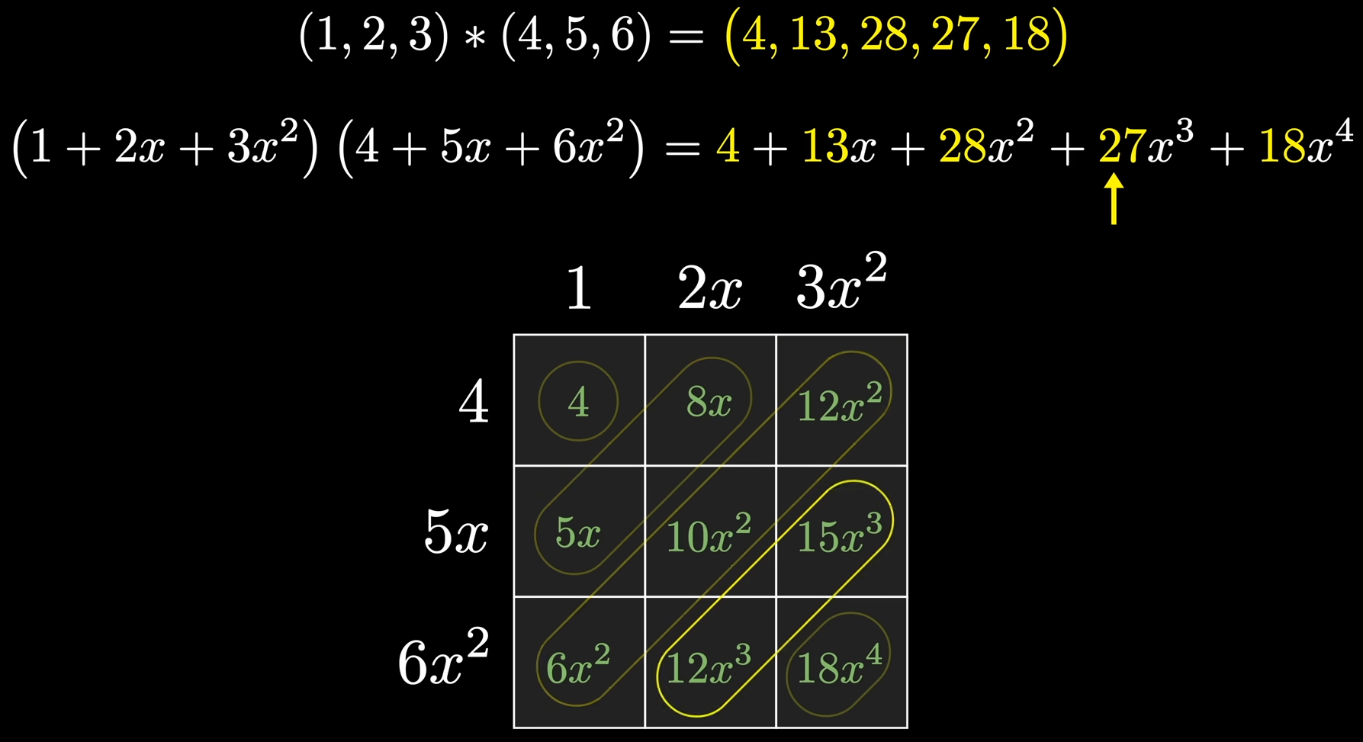
A convolution is a method for combining 2 sets of numbers. Like addition, multiplication, etc. <- It’s simple

It’s Polynomial Multiplication too!
Hooked on 3Blue1Brown videos, 1 min in.

A result of a convolution is the probability distribution of certain results when given 2 sets. Then add all results.

It can be used to get a moving average with a long a set and short b set. You can also weigh different parts of the moving average, eg. focus on the center. All numbers in b must add to 1.

Gaussian distribution = bell curve.

The smaller set/grid b is called a kernel. Convolution filter.

Convolutions are behind many image processing techniques. Gaussian blur, sharpen, etc.

In mathematical convolutions the b set is flipped before applying it. Remember the dice?

Pairwise products is what it sounds like <- It’s simple

A convolution on two polynomials is multiplying them and adding like terms. This means both methods of extracting coefficients & multiplying manually along with multiplying the resulting graphs give you the same output.

The coefficient method is O(N^2) while multiplying the outputs (graph) is O(N). Finding the outputs and multiplying is O(nlog(n)).

You need n points to find the equation for a polynomial with n terms!

Convolutional Neural Network Explained - Coding Lane
What is CNN in deep learning? Convolutional Neural Network Explained

3 layers per filter to use RGB. ie. 3x3x3, output is still a single layer.
- Depth wise convolution is similar, but outputs 3 layers. Eg. one per each colour, RGB. After this step, it’s possible to do point wise convolution and combine all 3 outputs into one. For a single pixel this would be R+G+B=x.

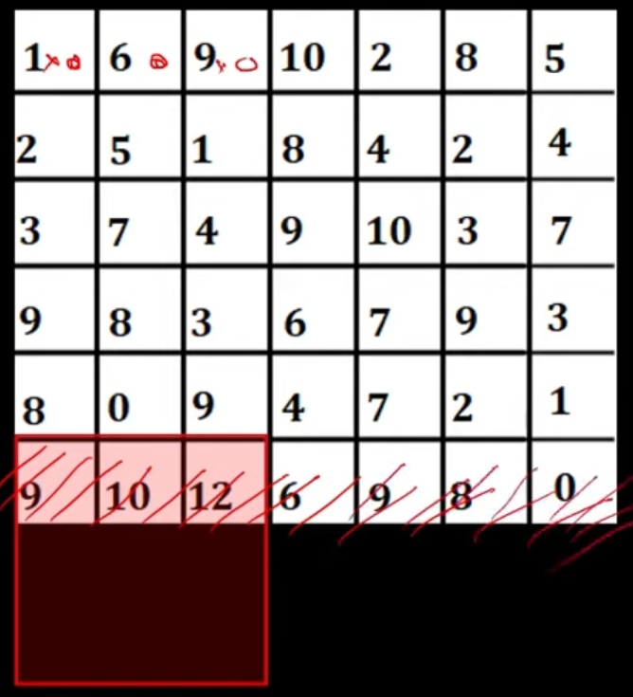
Valid Convolution = no padding
Same convolution = padding so that the output is the same size as the input

If the stride is not a perfect multiple of the length, the final values are discarded.

Floor((n - f)/s + 1) = dimension of output
n = length, f = filter length, s = stride length

Pooling layers reduce the size of an image while preserving the features.
Max, average, min, etc. <- It’s simple, downsampling
Reduce size & enhance features.

The features are flattened into a single layer that is passed into the Fully Connected Layer.

Convolution and max pooling layers when adjacent to each other are considered a single layer.

Backpropagation in CNN - Coding Lane
Backpropagation in CNN - Part 1

Derivatives Required - Derivative = slope

Compute the change in loss and for a given change in the value of a Neuron. Ie. dL/dX. Slope

W =W - alpha(dL/dK) <- update the weights like this?

Chain Rule Required

Cannot understand this guy

What is backpropagation really doing? - 3Blue1Brown
What is backpropagation really doing? | Chapter 3, Deep learning

Conv Net Basic Implementation Pytorch: https://machinelearningmastery.com/building-a-convolutional-neural-network-in-pytorch/

